
Project Initialization and Planning Phase
Date | 30 SEPT 2026
Team ID | SWTID-2026-9948
Project Name | EduGenie – Google Gemini Powered Learning Assistant
Maximum marks | 3 Marks

Step 1: Submission Checklist
S.NO | ITEM TO SUBMIT | SUBMITTED (YES /  NO/ NA)
1 | Complete source code (all files and folders) | Yes
2 | README / Setup Guide (instructions to run the project) | Yes
3 | requirements.txt / package.json / dependency file | Yes
4 | Database schema / seed files (if applicable) | Yes
5 | Environment configuration file (.env.example or similar) | Yes
6 | Deployed application URL (if hosted) | Yes
7 | Executable binary (if applicable for mobile/desktop apps) | NA
8 | Dockerfile / Containerization config (if applicable) | Yes
9 | Test files and test results | Yes
10 | Demo video or walkthrough (if required) | Yes

Step 2: File / Folder Structure

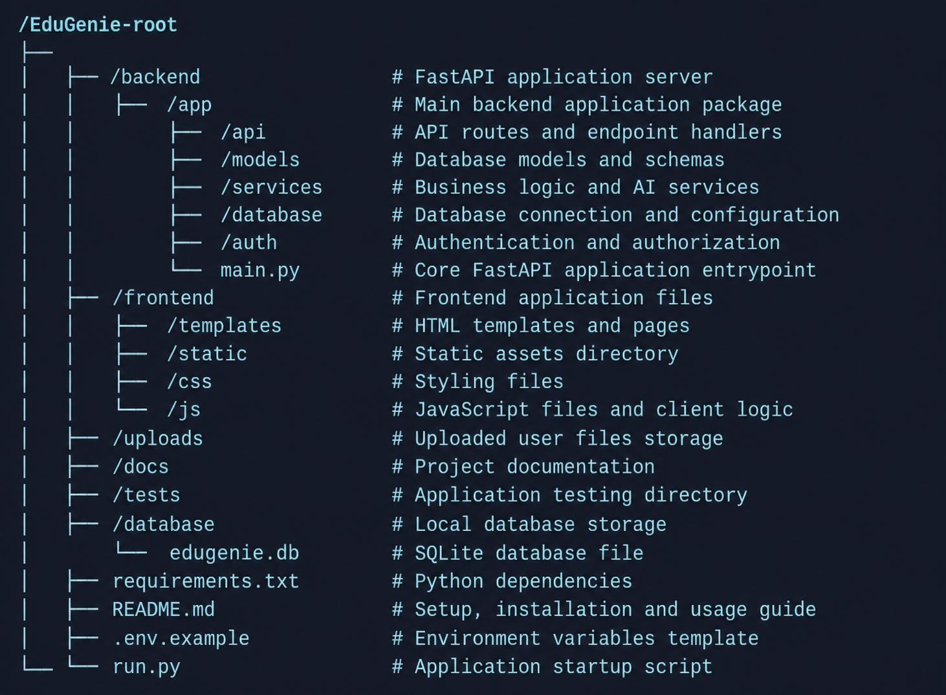

Step 3: Deployment / Access Details

Field | Details
Hosted URL | Your deployed URL
Demo Login | student@example.com / password123
Platform | Render / Railway / Vercel
Repository | Your GitHub Repository
Demo Video | Google Drive / YouTube Link

Step 4: Run Instructions
- Clone the repository.
- Open terminal.
- Install dependencies: pip install -r requirements.txt
- Configure .env: GEMINI_API_KEY=YOUR_API_KEY
- Start FastAPI: uvicorn backend.app.main:app --reload
- Open: http://127.0.0.1:8000
- Login and access all EduGenie AI features.

Step 5: Known Issues / Limitations
S.No | Issue | Status
1 | Gemini API latency during heavy traffic | Minor
2 | Internet connection required for AI responses | Expected
3 | Large prompts increase response time | Optimization planned

